Sample questions and responses collated from our database:

1. Which businesses have set sustainability goals and have not yet achieved them?

SELECT Businesses.name, Sustainability_Goals.goal_type, Progress_Tracking.current_value, Sustainability_Goals.target_value

FROM Businesses

JOIN Sustainability_Goals

ON Businesses.business_id = Sustainability_Goals.business_id

LEFT JOIN Progress_Tracking

ON Sustainability_Goals.goal_id = Progress_Tracking.goal_id

WHERE Progress_Tracking.current_value < Sustainability_Goals.target_value

OR Progress_Tracking.current_value IS NULL;

Find the total energy consumption for each user:

SELECT u.name, SUM(ec.usage_amount) AS total_energy_consumption

FROM Users u

INNER JOIN Energy_Consumption ec

ON u.user_id = ec.user_business_id

GROUP BY u.name;

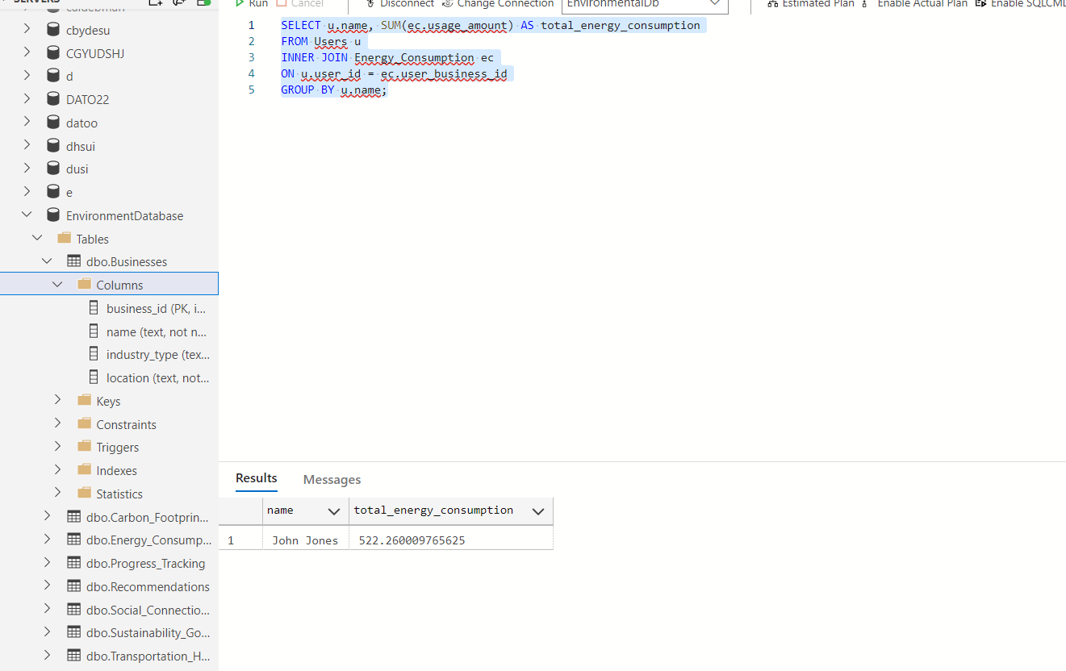

1. Find the average carbon footprint for businesses in a specific industry:

SELECT b.industry_type, AVG(cfc.carbon_footprint) AS avg_carbon_footprint

FROM Businesses b

INNER JOIN Carbon_Footprint_Calculations cfc

ON b.business_id = cfc.user_business_id

GROUP BY b.industry_type;

1. What is the total energy consumption of each user and business?

SELECT u.name AS Name, SUM(e.usage_amount) AS Total_Energy_Consumption

FROM Users u

INNER JOIN Energy_Consumption e

ON u.user_id = e.user_business_id

GROUP BY u.name

UNION ALL

SELECT b.name AS Name, SUM(e.usage_amount) AS Total_Energy_Consumption

FROM Businesses b

INNER JOIN Energy_Consumption e

ON b.business_id = e.user_business_id

GROUP BY b.name;

